Namibia

## GNI per capita and development level

The data set shows the GNI per capita and development level of the country each year.

## # A tibble: 19 x 5  
## country iso3c date GNIperCapita devCategory   
## <chr> <chr> <dbl> <dbl> <chr>   
## 1 Namibia NAM 1996 3810. Lower Middle Income  
## 2 Namibia NAM 1998 3955. Lower Middle Income  
## 3 Namibia NAM 2000 4105. Upper Middle Income  
## 4 Namibia NAM 2002 4252. Upper Middle Income  
## 5 Namibia NAM 2003 4497. Upper Middle Income  
## 6 Namibia NAM 2004 4804. Upper Middle Income  
## 7 Namibia NAM 2005 4728. Upper Middle Income  
## 8 Namibia NAM 2006 5015. Upper Middle Income  
## 9 Namibia NAM 2007 5048. Upper Middle Income  
## 10 Namibia NAM 2008 5096. Upper Middle Income  
## 11 Namibia NAM 2009 5006. Upper Middle Income  
## 12 Namibia NAM 2010 5114. Upper Middle Income  
## 13 Namibia NAM 2011 5339. Upper Middle Income  
## 14 Namibia NAM 2012 5440. Upper Middle Income  
## 15 Namibia NAM 2013 5859. Upper Middle Income  
## 16 Namibia NAM 2014 6068. Upper Middle Income  
## 17 Namibia NAM 2015 6254. Upper Middle Income  
## 18 Namibia NAM 2016 6009. Upper Middle Income  
## 19 Namibia NAM 2017 5887. Upper Middle Income

## GDP growth and economic growth classification

The data set shows the GDP growth and the ecomic growth classification of the country each year.

## # A tibble: 19 x 5  
## country iso3c date GDPannualGrowthRate GDPgrowthCategory4  
## <chr> <chr> <dbl> <dbl> <fct>   
## 1 Namibia NAM 1996 3.19 moderate growth   
## 2 Namibia NAM 1998 3.29 moderate growth   
## 3 Namibia NAM 2000 3.49 moderate growth   
## 4 Namibia NAM 2002 4.79 moderate growth   
## 5 Namibia NAM 2003 4.24 moderate growth   
## 6 Namibia NAM 2004 12.3 fast growth   
## 7 Namibia NAM 2005 2.53 moderate growth   
## 8 Namibia NAM 2006 7.07 fast growth   
## 9 Namibia NAM 2007 5.37 moderate growth   
## 10 Namibia NAM 2008 2.65 moderate growth   
## 11 Namibia NAM 2009 0.296 slow growth   
## 12 Namibia NAM 2010 6.04 fast growth   
## 13 Namibia NAM 2011 5.09 moderate growth   
## 14 Namibia NAM 2012 5.06 moderate growth   
## 15 Namibia NAM 2013 5.61 fast growth   
## 16 Namibia NAM 2014 5.76 fast growth   
## 17 Namibia NAM 2015 4.53 moderate growth   
## 18 Namibia NAM 2016 -0.281 negative grwoth   
## 19 Namibia NAM 2017 -0.256 negative grwoth

## Development trend

The plot shows the development trend of the country.

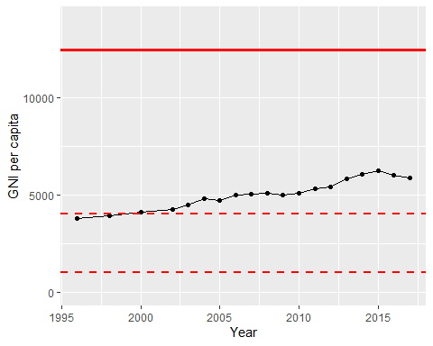

GNI Per Capita Trend